S317: Spanish Conversation and Diction—Study Abroad Service Learning in the Dominican Republic --- May 8-24, 2022
https://spark.adobe.com/page/qJvDNc1L5pFHq/

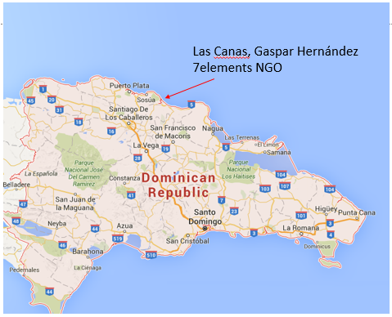
What is the program?
- Course: S317- Spanish conversation and diction (can be taken twice for credit) taught by IU Professor Erik Willis
- Service: we will partner with 7elements (http://7elementsdr.org/) to provide service to the local communities in several projects including, building bottle buildings, laying cement floors, providing community education on water filters, and cacao reforestation projects, among others.
- Food and lodging: provided by staff at the 7elements lodge —including at our service projects. Mosquito nets are included with beds.
The lodge is in Las Canas and is located 200 yards from the beach. The lodge is protected by a fence, guard dog, and watchmen.
QR code is an overview in Adobe Spark

- Additional cultural excursions: we will visit Sosúa beach to snorkel and barter, the city of Santiago to tour the Centro León anthropology museum, Laguna Gri-Gri to visit a small downtown plaza among others.
- Predeparture: orientation and assignments are expected.

Where: Las Canas, Dominican Republic (on the north coast)
When: May 8-24, 2022 (application deadline January 2022)
Who is eligible for the program? The program is designed for students who wish to be involved in an international service project and practice their Spanish while earning credits toward graduation. All IU students are eligible that have taken S280 and received a B (3.0 GPA) or above. The application requires two letters of recommendation and a statement from the student.
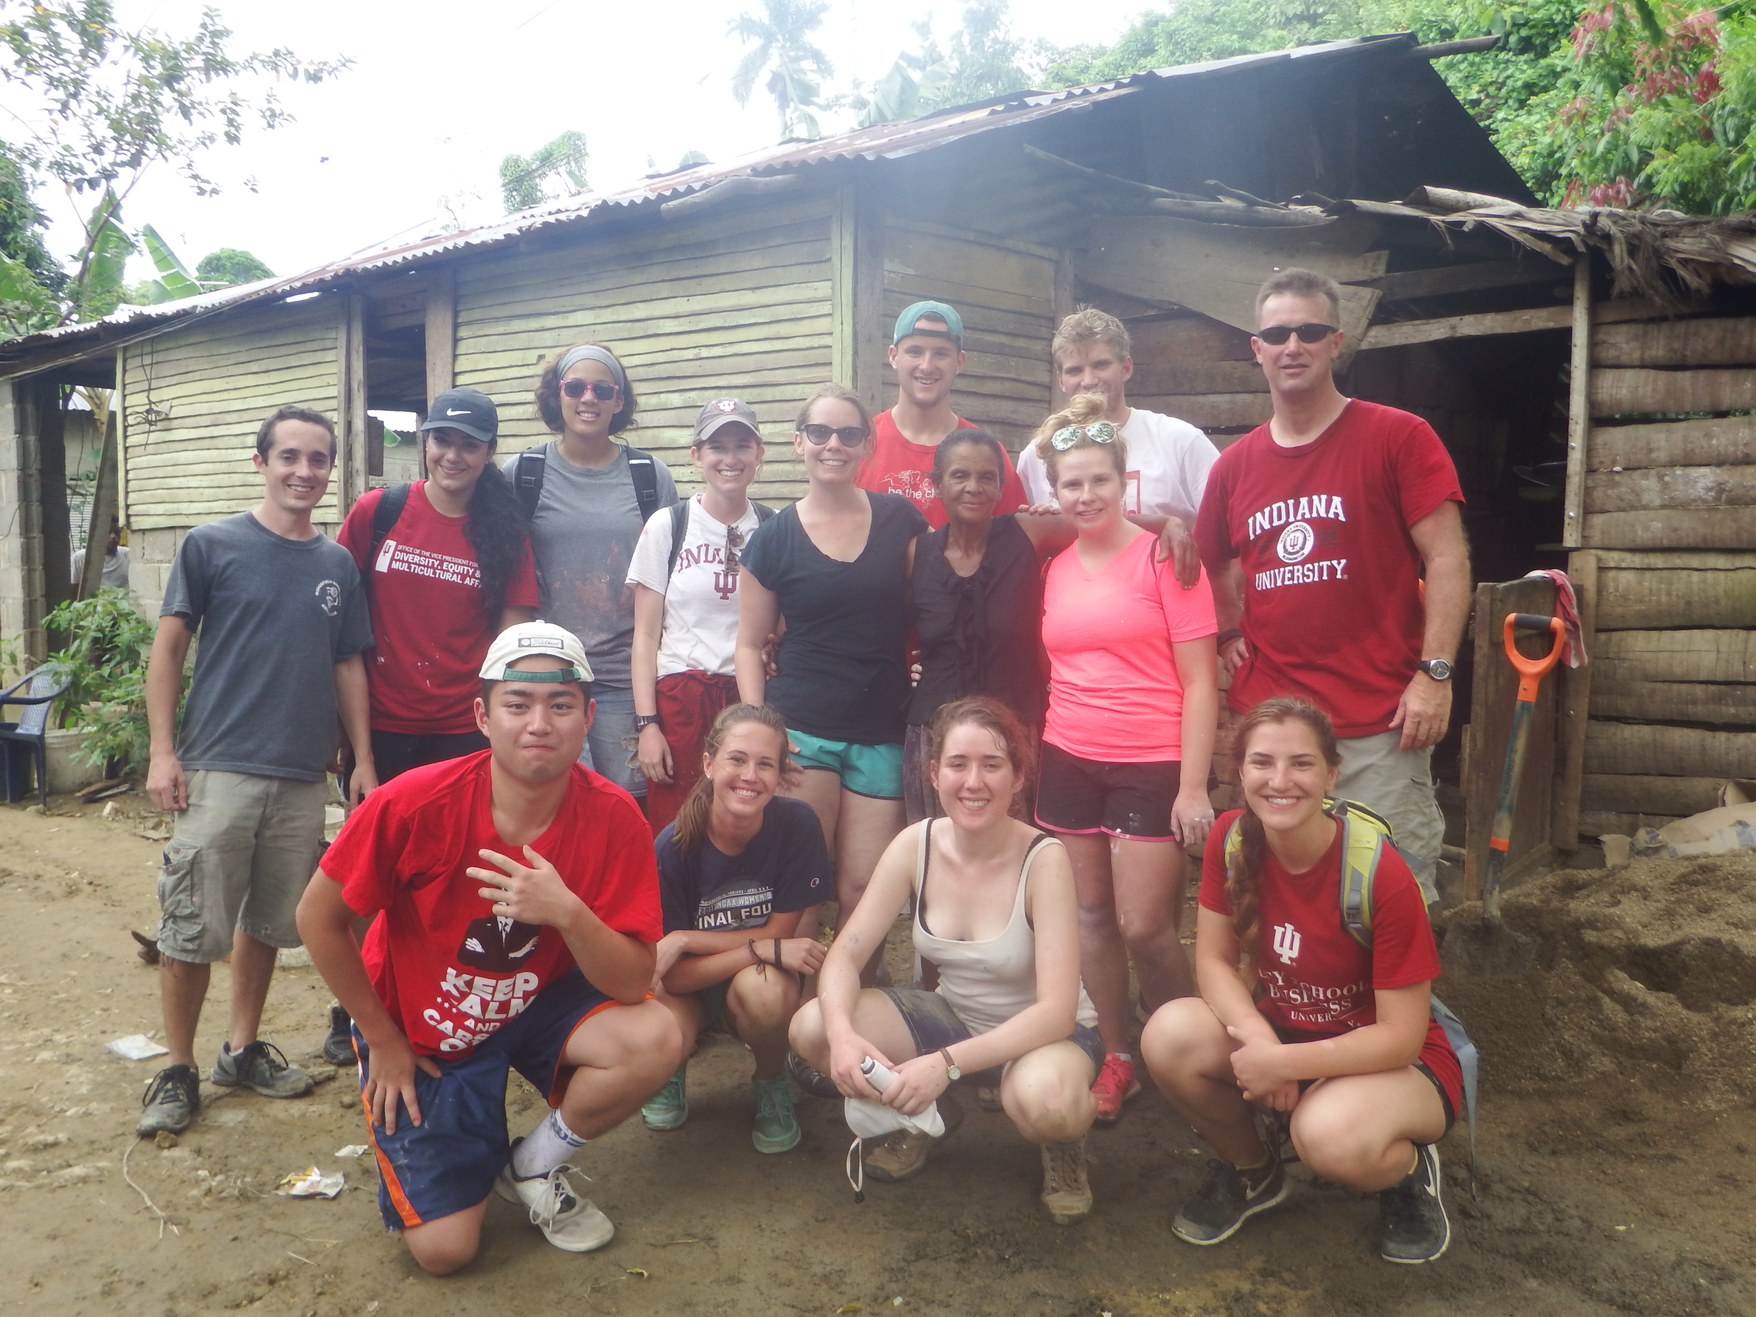
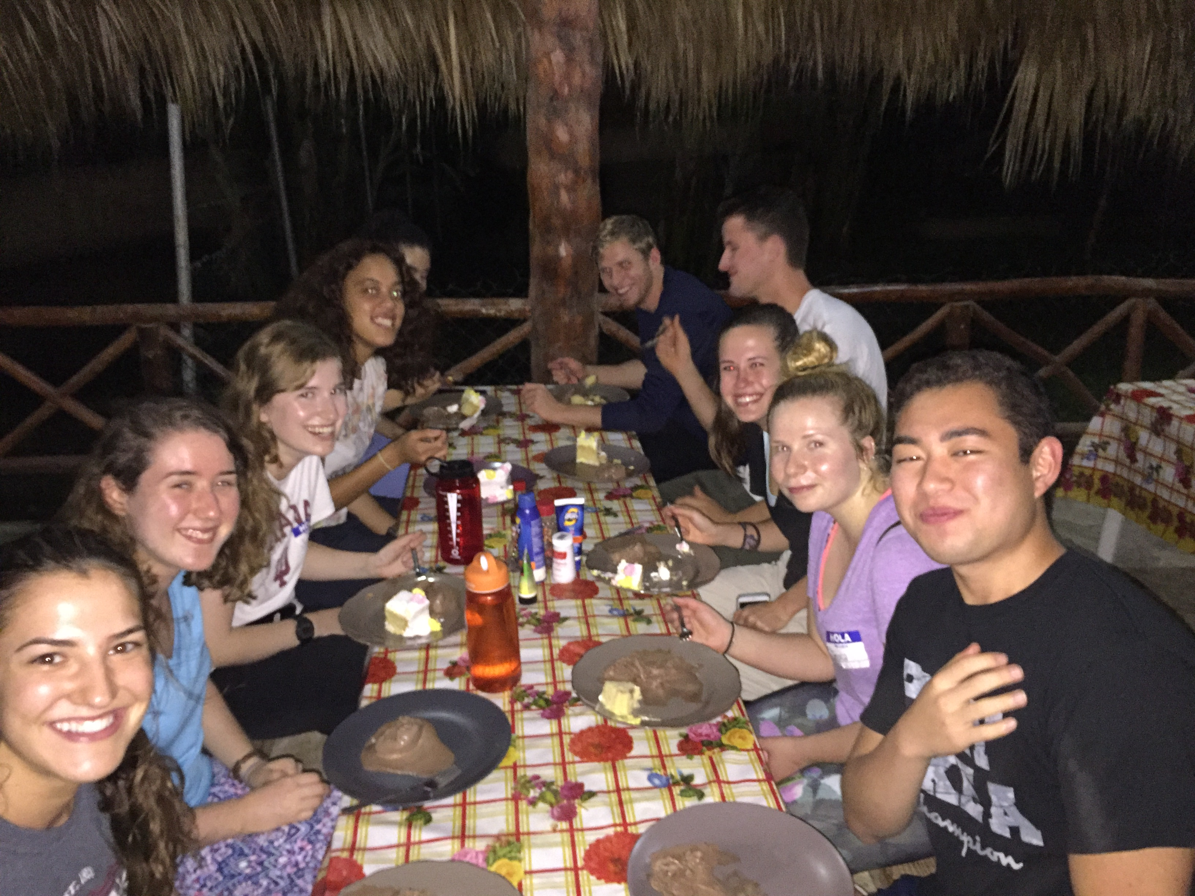
Cost: ($2,646 +/- resident) Includes room and board, tuition, fees, Health insurance in the Dominican Republic, and excursions. Students are responsible for airfare.
How to apply: Application information will be available at
https://overseas.iu.edu/programs/iu/unit-based/iub/spanish-conv-dr.html

Contact Prof. Erik Willis, ewwillis@iu.edu for additional information.

